**LAB EXPERIMENT – 7**

**LAN KALI LINUX**

**IP CONFIG to check the IP for the Device.**

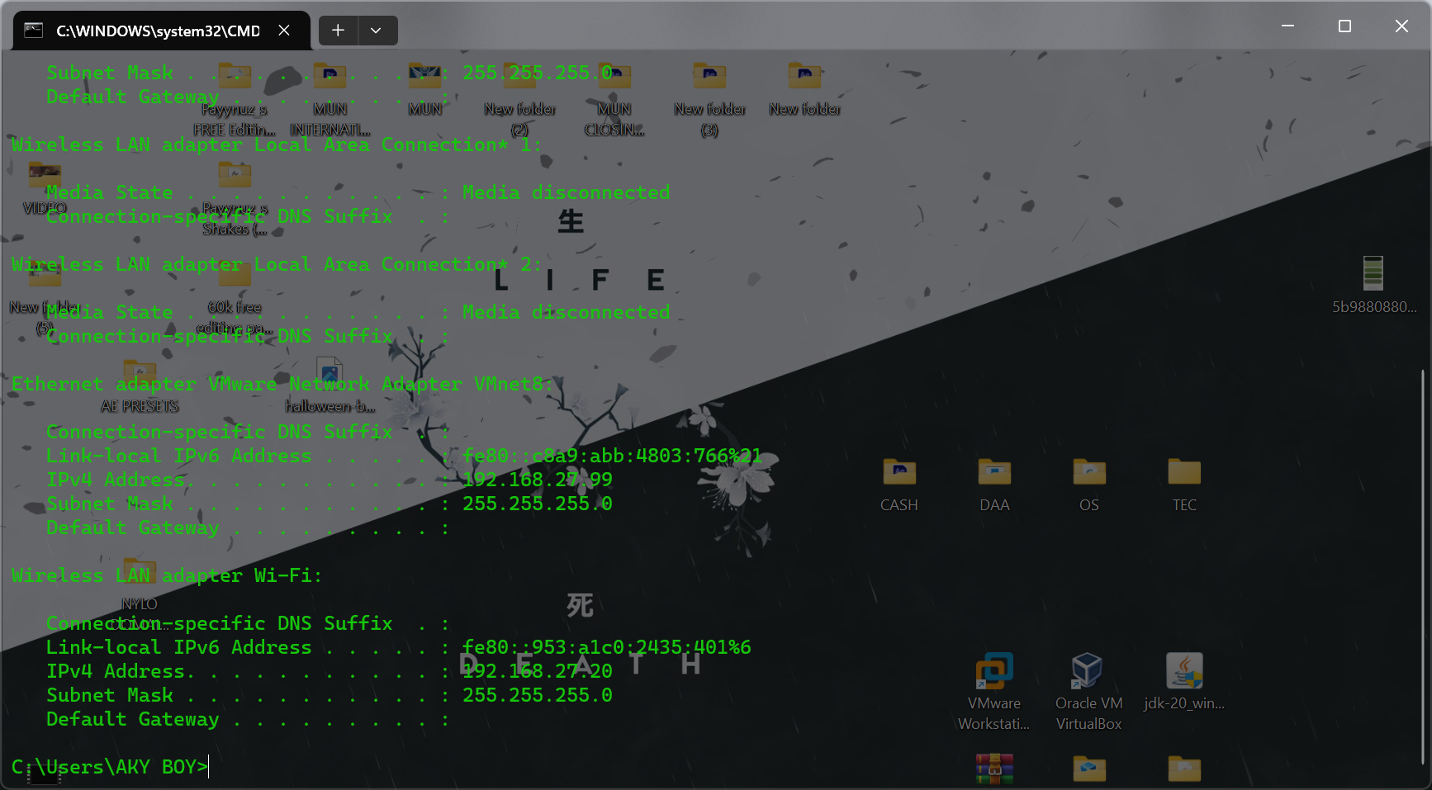

**CONFIGURATION IP**

**Turn off the Firewall for the both the devices.**

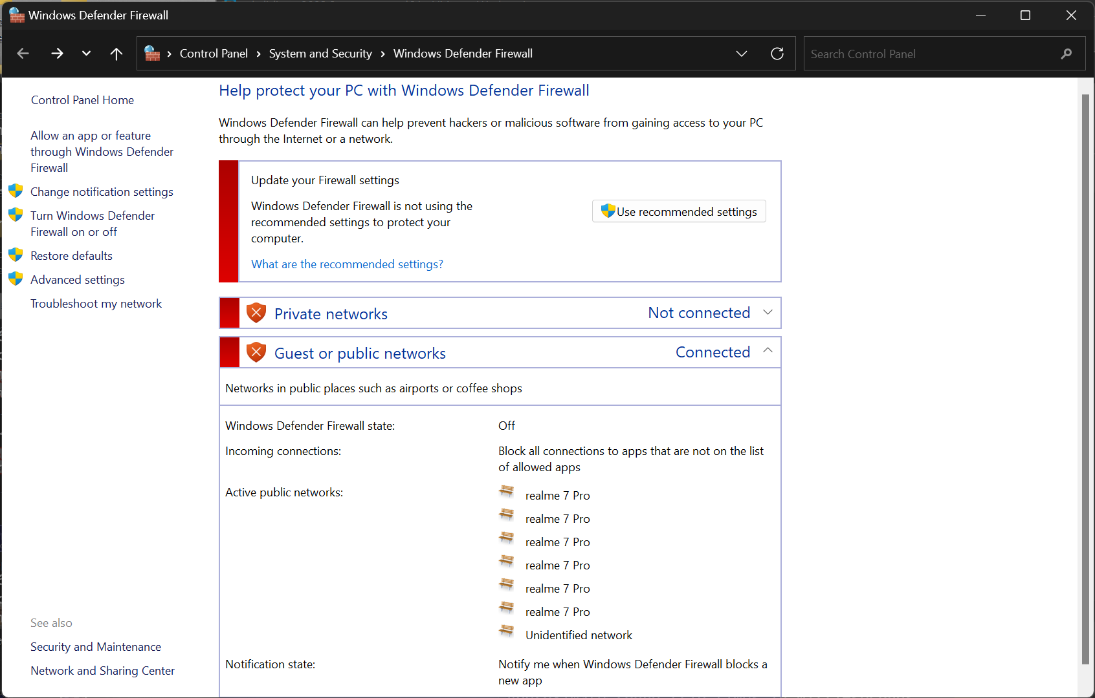

**Go for the Properties**

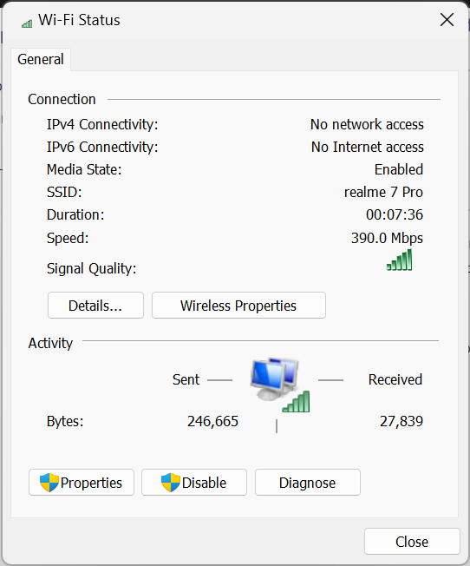

**Go for the IPV4 to configure the custom Static IP for your device.**

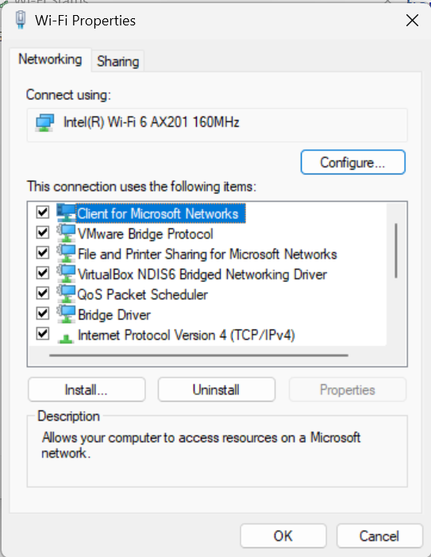

**IP for my device is 192.168.27.20**

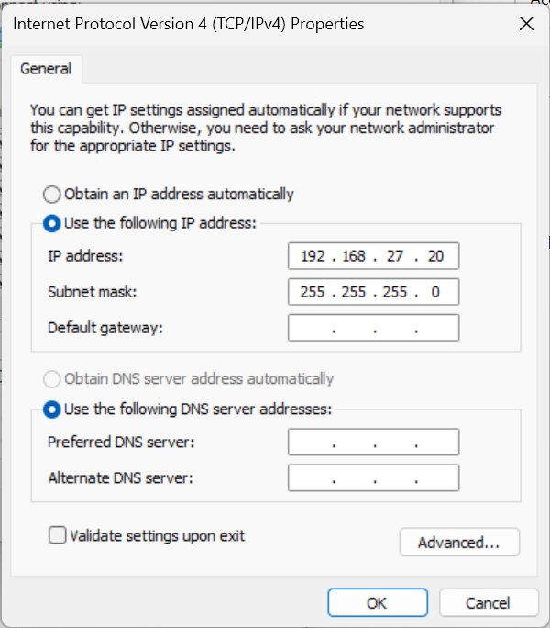

**2nd DEVICE IP – 192.168.27.10**

**3rd Deevce IP – 192.168.27.11**

**4th Device IP – 192.168.27.12**

**3rd DEVICE**

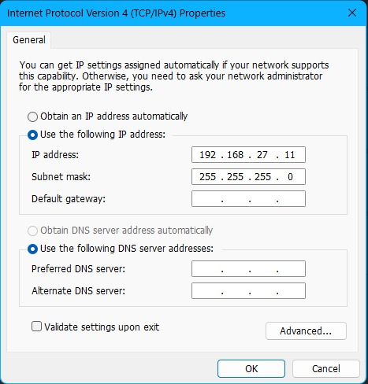

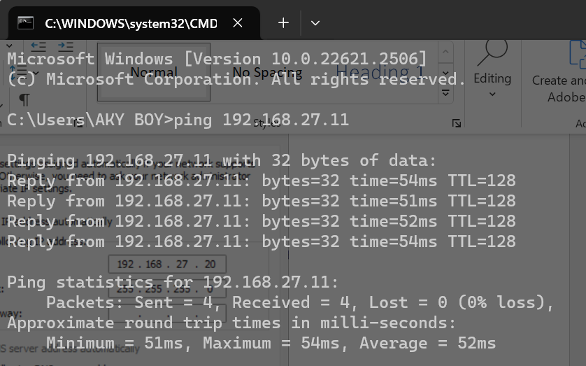

**2nd DEVICE**

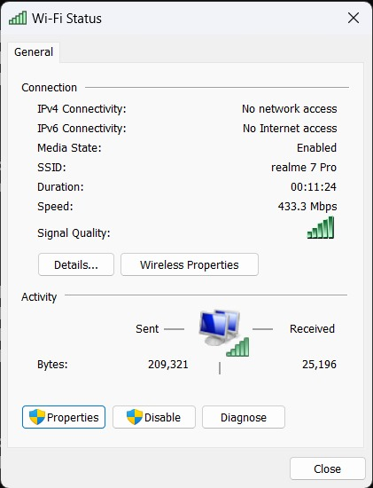

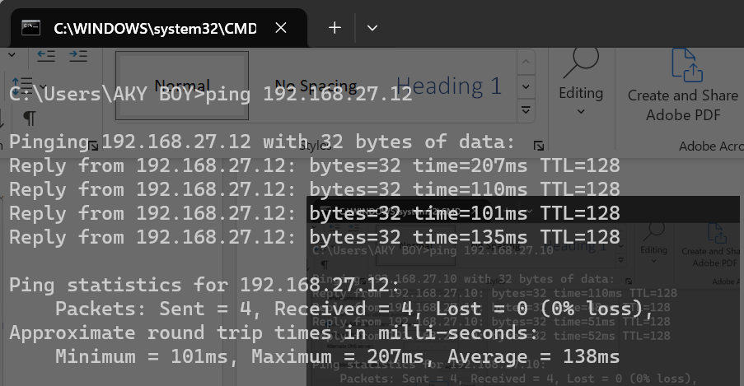

**4th DEVICE**

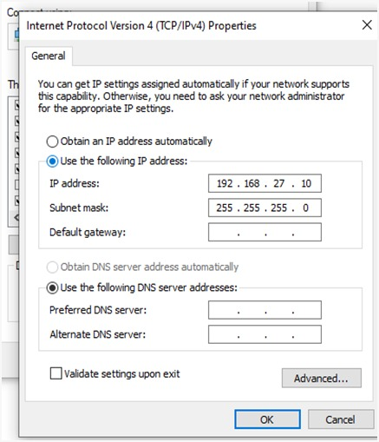

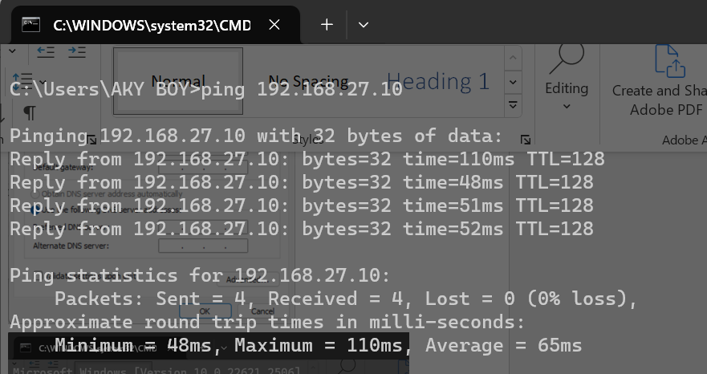

**SELF VM TO OTHER DEVICE WINDOWS**

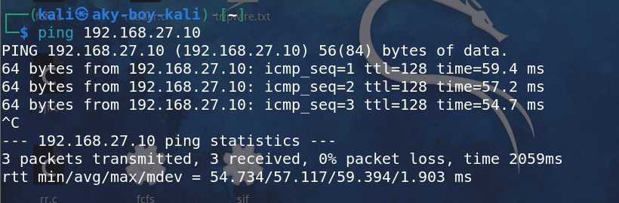

**PING FROM VM TO SELF DEVICE**

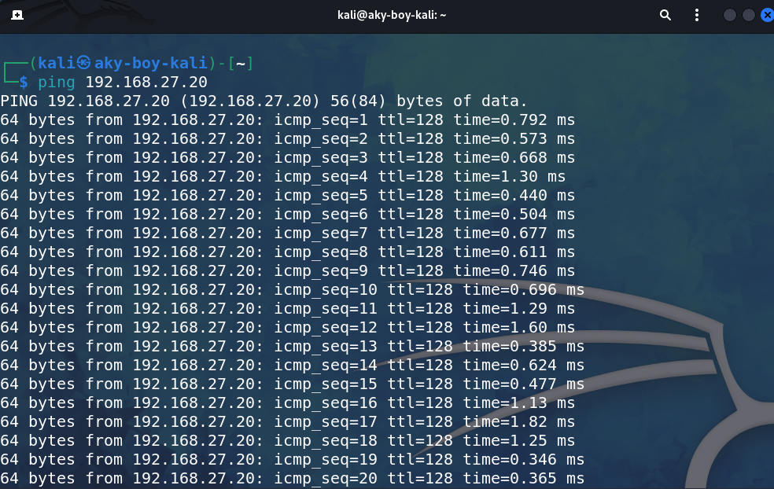

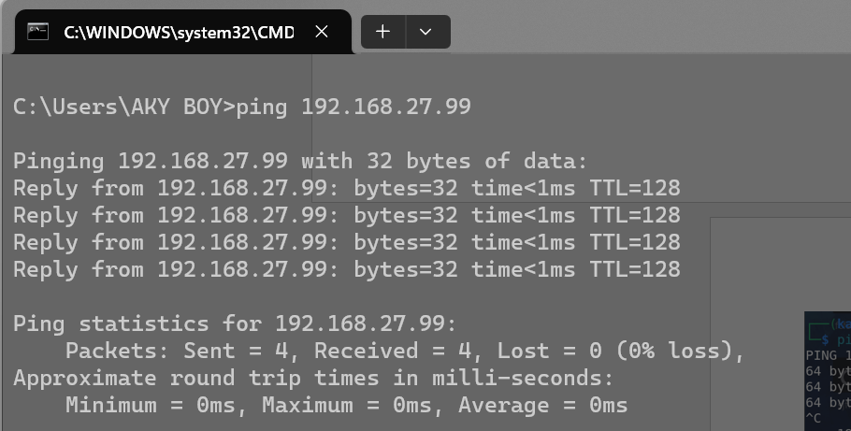**PING FROM WINDOWS TO SELF VM**